CMPG 325 – COMPUTER NETWORKS MILESTONE 2
Student | MOLEWA, MS
Student Number | 43628362
Project ID | CMPG325-2026-084
Client ID | CLI-084
Assigned Organisation | Ramothibe Labour Law Consultants (Kimberley)
Industry | Legal Services

1. Functional Requirements
1. Provide reliable connectivity between the required client devices and network services.
2. Use the assigned IPv4 addressing block: 172.30.54.0/23.
3. Implement VLANs to logically separate relevant categories of network traffic.
4. Implement IEEE 802.1Q trunking between switches so that multiple VLANs can traverse the relevant inter switch links.
5. Provide appropriate Layer 3 connectivity between VLANs where required by the organisation.
6. Provide a dedicated logical network for voice traffic to accommodate the CR11 VoIP change request.
7. Provide appropriate network management addressing for network infrastructure devices.
8. Provide sufficient addressing capacity for the expected growth of the organisation.
9. Ensure that the final design can be implemented and tested in Cisco Packet Tracer.
10. Ensure that the completed network can demonstrate successful connectivity and operation through appropriate testing.

2. Physical Topology
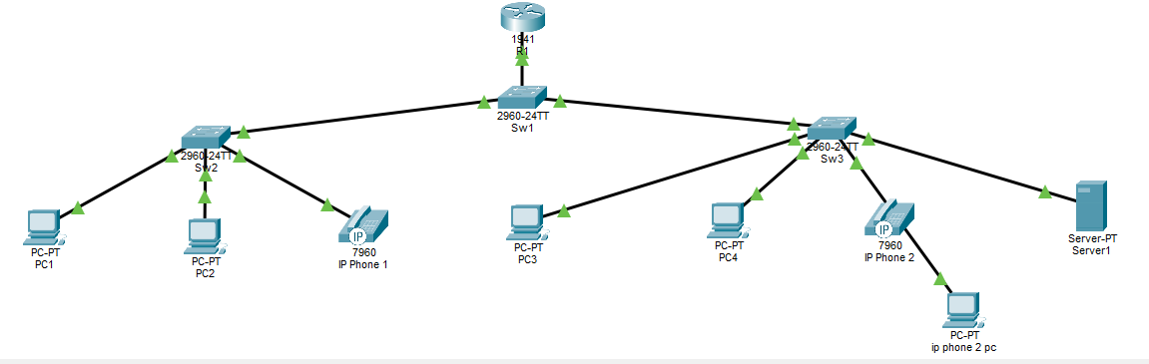
Due to Cisco Packet Tracer limitations I had to alter my topology a bit to make my addressing plan work. I added IP Phone 2 PC so that the ip address 172.30.54.130 could function correctly, because 7960 IP Phone settings button does not work, hence I wasn’t able to add the IP address to the ip phone itself.

3. IP Addressing Plan

VLAN | Name | NETWORK
10 | STAFF-DATA | 172.30.54.0/25
20 | VOICE | 172.30.54.128/26
30 | MANAGEMENT | 172.30.54.192/27
40 | SERVERS | 172.30.54.
99 | NETWORK-MGMT

4. Assigned features
The assigned feature for this project is the implementation of static IP address 172.30.54.130 within the voice VLAN.
Implementation Details
- Network: VLAN 30 VOICE, 172.30.54.128/26 (Mask 255.255.255.192)
- Assigned IP: 172.30.54.130
- Gateway: 172.30.54.129 (R1 sub-interface g0/0.30)
- Device: Host connected to ip phone 2’s pc port (Sw3 f0/3)
- Switchport configuration: Switchport access vlan 10, switchport voice vlan 30
Then due to Cisco 7960 firmware limitations, the phones’ settings button in GUI is non-responsive, hence the assigned IP was implemented on the end device attached toIP phone 2’s pc port which resides in VLAN 30.
Inter-VLAN connectivity to 172.30.54.130 was verified from vlan 10 host pc4 (172.30.54.14) with all successful ICMP responses, proving good routing and trunking functionality.
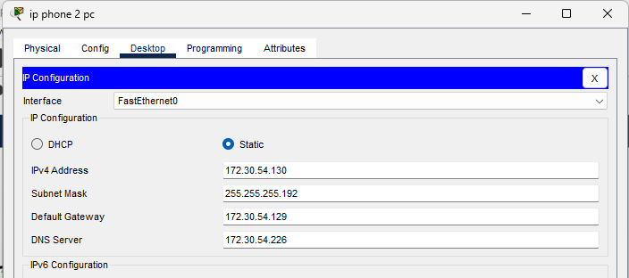
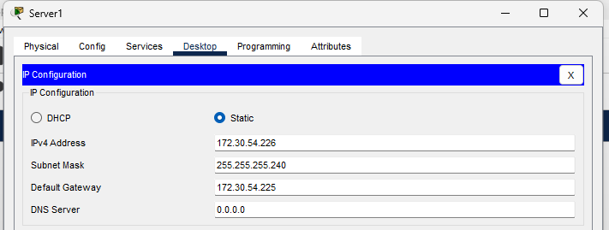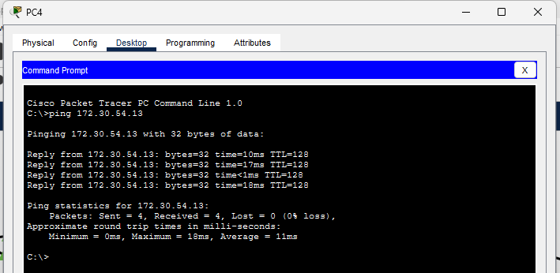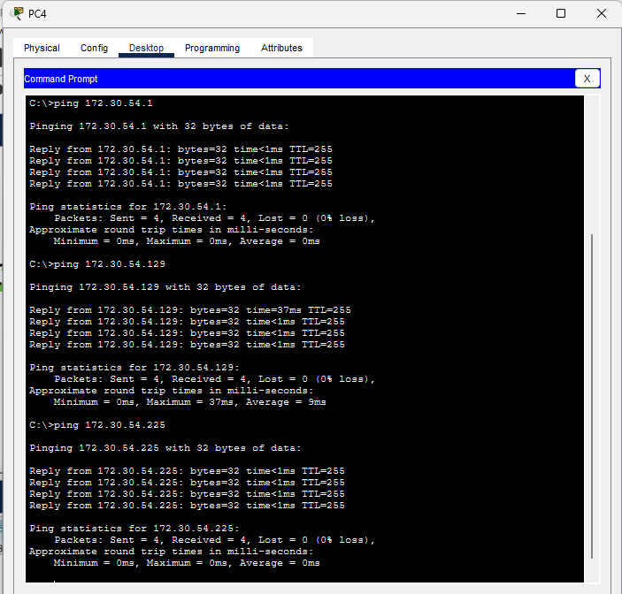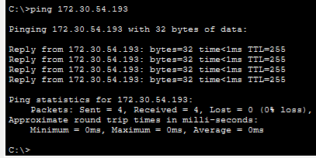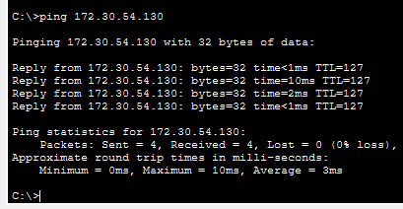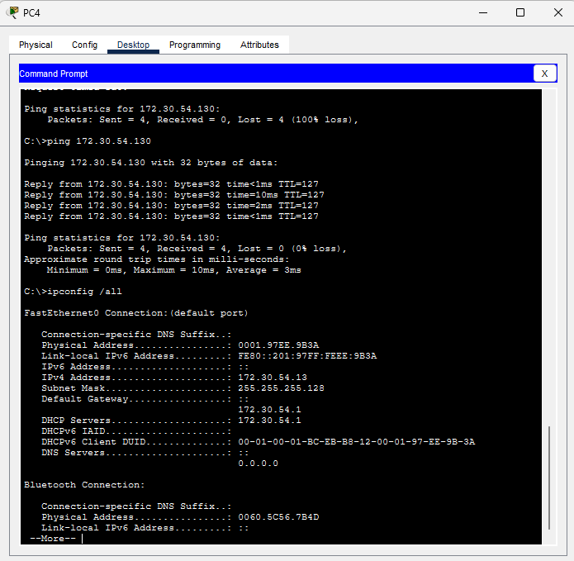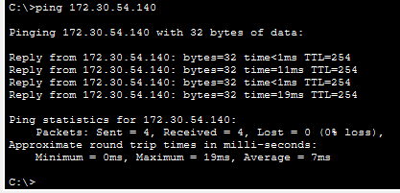
5. Remaining Tests
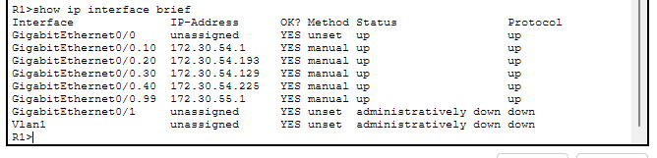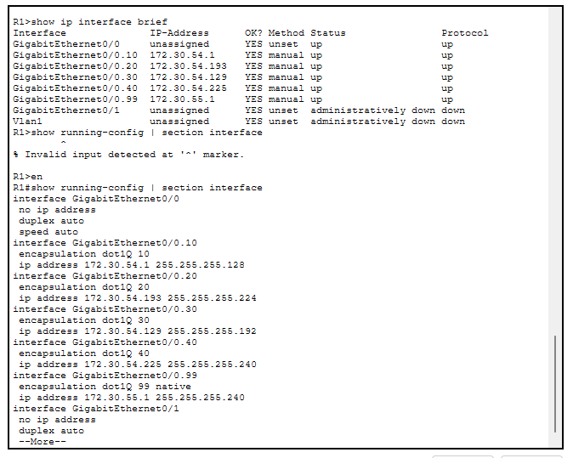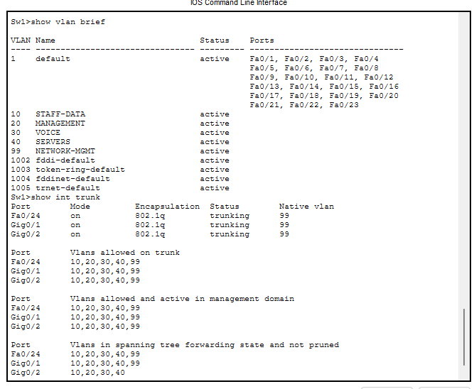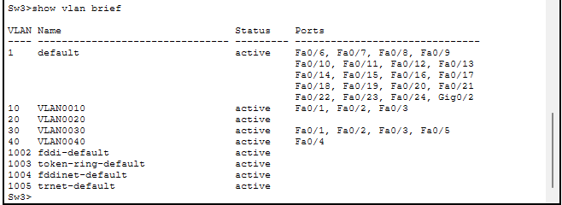

Github repository link

